TRI-FORCE
IT & SECURITY SYSTEMS
TRI-FORCE IT& SECURITY SYSTEMS
11 Hans-schoeman street malanshof center randburg 2194
JAN LEGODI
INDEX
i. INTRODUCTION i
TABLE OF CONTENT 1
1.*ELECTRIC FENCING 1
1.1-Energizer (Domestic/industrial) 2
1.2-wall top electric fencing 3
1.3-attach electric fencing 4
1.4-free standing fencing 5
1.5-upgrading 6
2.*ACCESS CONTROL SYSTEMS 7
2.1-Estate and corporate intercoms 8
2.2-Domestic intercoms 9
2.3-Access and readers 10
2.4-Booms and traffics barriers 11
2.5-SMS intruder notification 12
2.6-Infrared beams and perimeter control 13
3.*GARAGE AND GATE AUTOMATION 14
3.1-Sliding gate motors 15
3.2-Swing gate motors 16
3.3-Garage motors 17
3.4-centurion D5 D10 gate motors 18
4.*CCTV CAMERAS 19
4.1-domestic CCTV security cameras 20
4.2-corporate CCTV cameras 21
4.3-Industrial CCTV cameras 22
i

5.*ALARMS 23
5.2-IDS alarms 24
5.3-NAPCO alarms 25
5.4-Alarms sensors 26
5.5-Alarm accessories 27
6.*IT AND NETWORKING 28
7.* MAINTENANCE 29

ii
TRI-FORCE
IT & SECURITY SYSTEM
THE PURPOSE OF THIS COMMUNICATION IS TO INTRODUCE TO YOU TRI-FORCE IT AND SECURITY SYSTEM (PTY)LTD AND OFFER OVERVIEW THAT ENABLES YOU TO BECOME AU FAIT WITH OUR SERVICES, VALUES ,PEOPLE AND DREAMS.
MISSION STATEMENT
TO SUPPLY, INSTALL AND MAINTAIN A FULL RANGE OF COMPREHENSIVE SECURITY SOLUTIONS THAT OFFERS OUR CLIENTS OVERALL SAFETY AND PEACE OF MIND.
TRI-FORCE IT AND SECURITY SYSTEMS (PTY)LTD HAVE ETHICS OF INTEGRITY TO DELIVER A SERVICE THAT IS NOT JUST ACCEPTABLE BUT THAT WILL ALWAYS EXCEED EXPECTATIONS, BUILDING ON LONG-TERM RELATIONSHIPS WITH OUR CLIENTS.
WE MAKE IT OUR MISSION TO SUPPLY AND INSTALL SECURITY SYSTEMS THAT WILL ENSURE THE SAFETY OF YOUR FAMILY, POSSESSIONS AND STAFF OR BUSSINESSES.
VISION
TO MEET AND EXCEED OUR CLIENT`S SECURITY NEEDS AND REQUIREMENT BY PROVIDING THEM WITH UNRIVALLED PROFFESSIONAL SERVICE.
iii
VALUES
TRI-FORCE IT AND SECURITY SYSTEM IS A GROUP OF COMPANY THAT IS NOT AN ORDINARY SECURITY INSTALLER PASSIONATE ABOUT THE SAFETY OF OUR CLIENTS, WE PROVIDE SECURITY SOLUTIONS THAT ALWAYS ALLOWS YOU TO BE AT LEAST ONE STEP AHEAD OF CRIMINALLY INCLINED. AND AT THE VERY SAME TIME SUPPLY YOU VALUE OF MONEY.
WE ALSO SUPPLY IT SOLUTION AND PROVIDE EFFICIENT AND EFFECTIVE SYSTEMS THAT ENHANCED USING VARIETY OF PRODUCTS PRODUCED BY MANUFACTURES WITH THE PROVEN TRACK RECORD OF STABILITY AND RELIABILITY
THIS COMBINED WITH SOUND ADVICE FROM OUR STAFF, GIVEN A VARIETY OF CHOICE IN THE FANAL DESIGN OF THEIR SYSTEMS.
THIS SYSYEMS ARE INSTALLED AND SERVICED BY A NETWORK OF EXPERIENCED WELL-TRAINED STAFF.
iv
OPERATIONS
TRI-FORCE IT AND SECURITY SYSTEMS (PTY) LTD OPERATES THEIR HEAD OFFICE AND CENTRAL POINT OF ADMINISTRATION FROM:
11 HANS-SCHOEMAN STREET
MALANSHOF CENTER
RANDBURG
2194
JOHAN ELS (CEO)
TELEPOHONE:(+27)11 568 9803
CELL PHONE(+27) 72 971 7003
EMAIL ADDRESS:johan@tri-force.co.za
LINDY PHALANE (ADMINISTRATOR)
TELEPHONE:(+27) 11 568 9803
CELL PHONE:(+27) 61 508 1993
EMAIL:lindy@tri-force.co.za
THATO SETHOLE (EXECUTIVE SALES CONSULTANT)
TELEPHONE:(+27) 11 568 9803
CELL PHONE:(+27) 76 739 2848
EMAIL:thato@tr-force.co.za
LEONESE PALMER (EXECUTIVE SALES CONSULTANT)
TELEPHONE:(+27) 11 568 9803
CELL PHONE(+27) 63 355 0421
EMAIL: leonese@tri-force.co.za
JAN LEGODI (EXCECUTIVE SALES CONSULTANT)
TELEPHONE:(+27) 11 568 9803
CELL PHONE:(+27) 72 751 7998
EMAIL: jan@tri-force.co.za
v
TABLE OF CONTENT
1.ELECTRIC FENCES
-The main purpose of electric fencing is to keep the intruder out. It secures the residents inside the perimeter and protect their properties and valuables.
-Electric fence is of no use if it cannot warn you of an intrusion.
-Electric fencing are designed to supply the electric fence with power.
-We have Energizers
-They can be divided into two categories *domestic and
*Industrial
-Wall top fencing can be installed on top of the walls.
-At TRI-FORCE we provide advanced products and all-round security features that you can rely on with ease.
-Attach electric fencing are the first lines of defense against criminals.
-The are used as the first barriers of security in South Africa.
-Freestanding fences are very effective to keep the intruder out.
-They provide electric shock to intruder.
-Ease to operate.
-We also do upgrade, we replace products.
-Provides more complete solutions that implement upgrades in the safe atomic ways.
1
1.1. ENERGIZER (DOMESTIC/INDUSTRIAL)
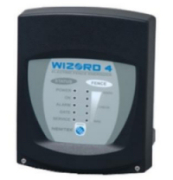 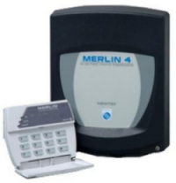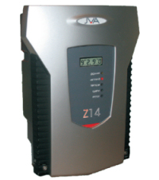
2
1.2. WALL TOP ELECTRIC FENCING
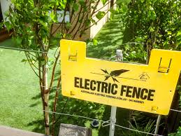
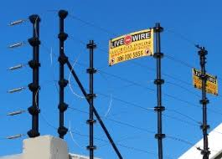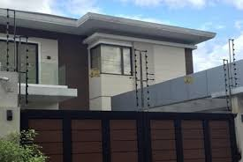

3
1.3 ATTACH ELECTRIC FENCING
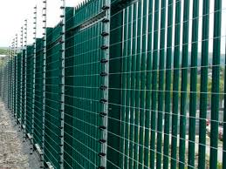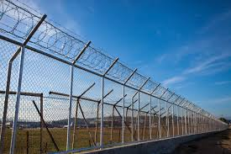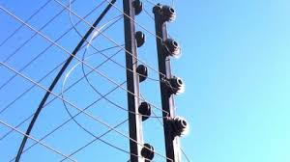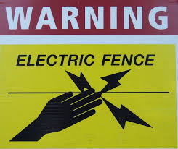
4
1.4.FREESTANDING FENCING
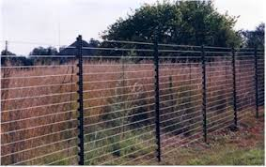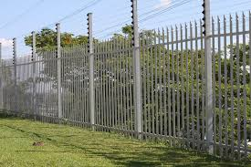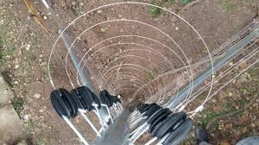
5

1.5.UPGRADING
6

2.ACCESS CONTROL SYSTEM
-At TRI-FORCE SECURITY SYSTEM we have different intercoms system
*Estate and corporate intercoms
*Domestic intercoms
-Estate and Corporate intercoms uses the cellular phone to connect to the residents.
-The system is fully programmable via the internet.
-Residents numbers can be changed over the internet.
-Access basic system can be upgraded to enable users to inter communication.
-Readers system can operate as stand-alone readers.
-Traffic barriers are used to control high volumes of traffic entrances.
-These systems can be activated by tag readers and expand to suit the clients’ needs.
-Home security is topic that almost all of us are well-versed in nowadays.
-SMS intruder notification system can warn you of possible danger and escalate the warning at the problem becomes more threatening.
-The level of warning can be set to elevate, eventually adding sirens and armed response call if require as the level of intrusion become more threatening
7
2.1.ESTATE AND CORPORATE INTERCOMS
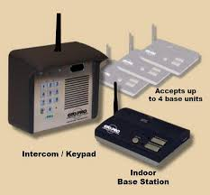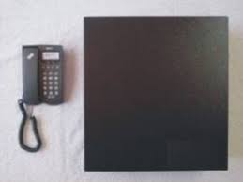
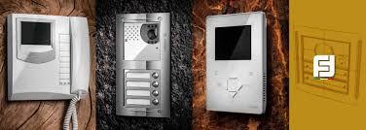
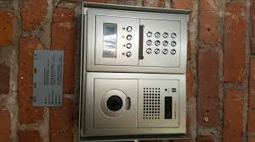
8
2.2. DOMESTIC INTERCOMS
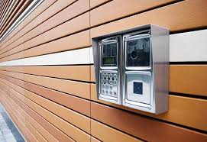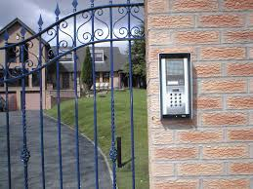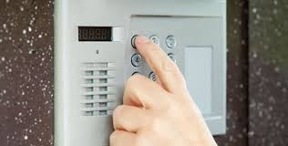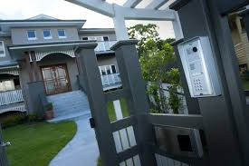
9
2.3. ACCESS AND READERS
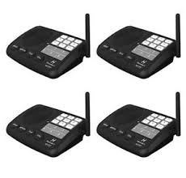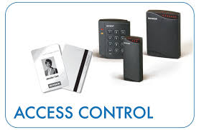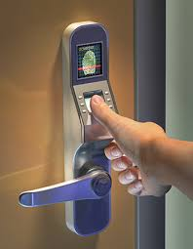
10
2.4. BOOMS AND TRAFFIC BARRIES
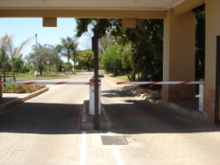
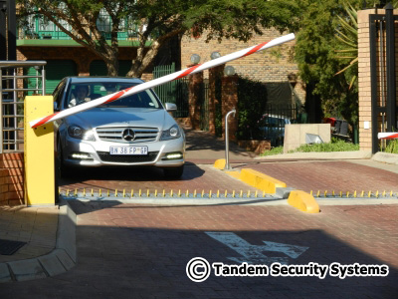

11

2.5.SMS INTRUDER NOTIFICATION
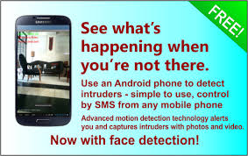
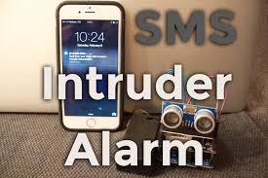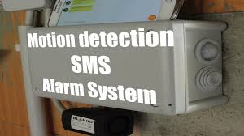

12
2.6 INFRARED BEAMS AND PERIMETER CONTROL
- 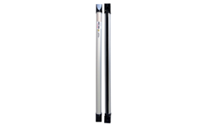 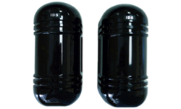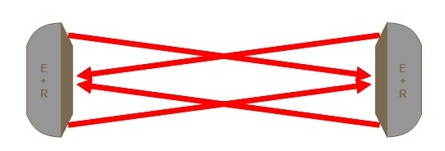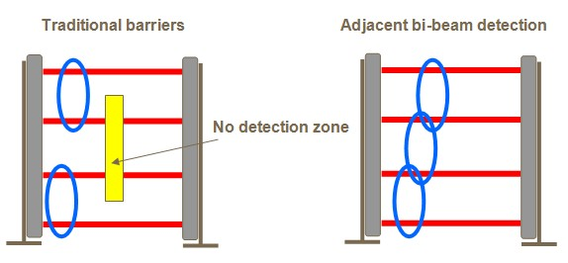
13
3.GARAGE AND GATE AUTOMATION
-At TRI-FORCE we install the best sliding and swinging gate motor.
-Our installer are also fully qualified technicians who are well trained to repair gate and garage motors on the site.
-Garage door automation is a service we normally provide hand in hand with gate automation.
-It is possible to operate both gate and garage door motor with the same remote.
-We provide Centurion D5 D10 gate motor.
-We also supply you with and install a safety on your garage door to prevent it from closing on your cars.

14
3.1 SLIDING GATE MOTORS
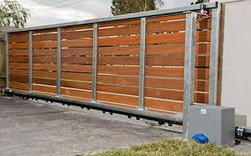
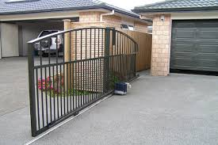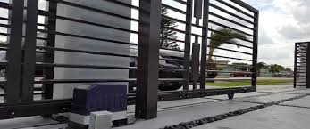
15
3.2.SWING GATE MOTOR
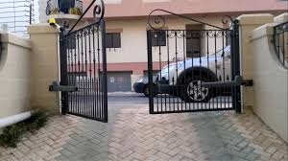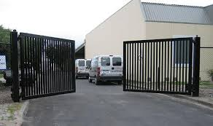
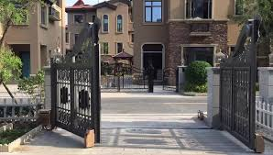
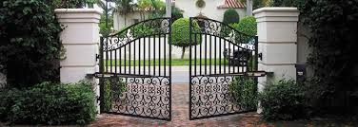

16
3.3.GARAGE GATE MOTOR
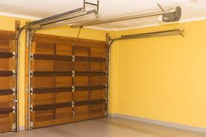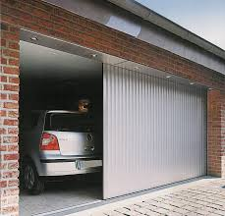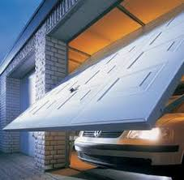
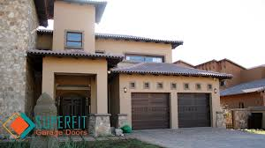

17
3.4. CENTURION D5 D10 GATE MOTORS
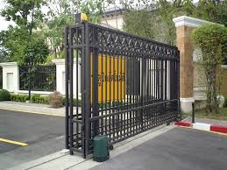
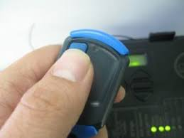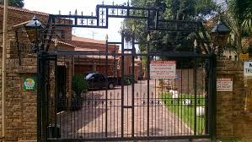
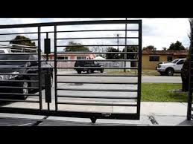
18
4.CCTV CAMERAS
-At TRI-FORCE we have intercoms system with clear or black and white cameras installed in all are of your choice and video built into the handset in the house
-The system are functional and the pictures quality are very high
-Cameras can be connected to a loose monitor inside the house.
-Large systems are used in factories, shopping center and at offices
-We can also use sophisticated system that has many advantage
*Digital record
*Can be connected to the internet
*Setting alarms and etc.
19
4.1.DOMESTIC CCTV SECURITY CAMERAS
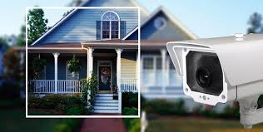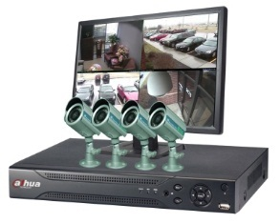
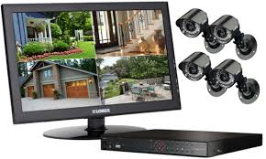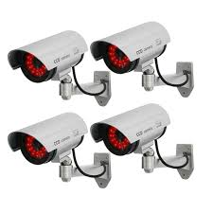
20
4.2.CORPORATE SECURITY SECURITY CAMERAS
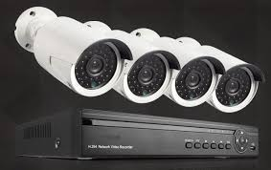

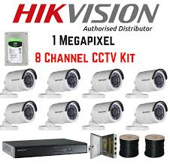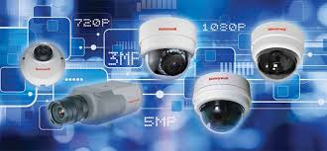

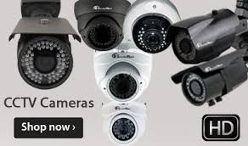
21
4.3.INDUSTRIAL CCTV SECURITY CAMERAS
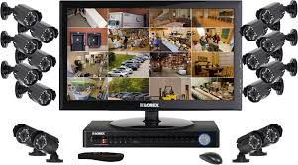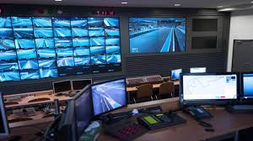
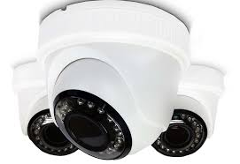
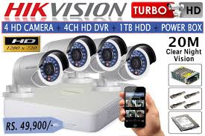
22
5.ALARMS
-Whether is a household or in a business operation TRI-FORCE has security solutions for you.
-An alarm system from TRI-FORCE is always suited to your needs and budget.
-Our alarms incorporate the latest technology and are built to be effective and reliable for years at a time.
-We install new or upgrade your existing ones.
-We supply *IDS alarms
*NAPCO alarms
*Alarms Sensors
*Alarms Accessories and etc.

23
5.1. IDS ALARMS
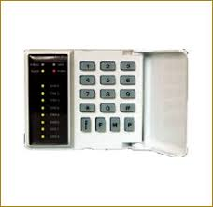
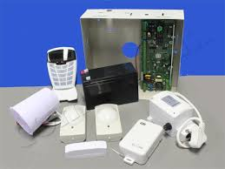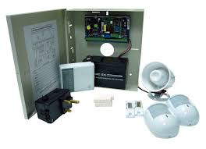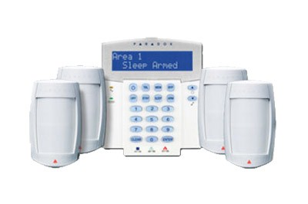
24
5.2. NAPCO ALARMS

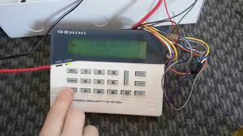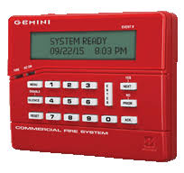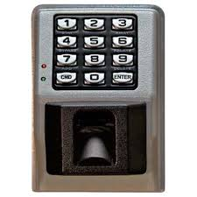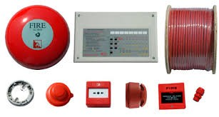
25
5.3.ALARMS SENSORS
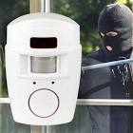 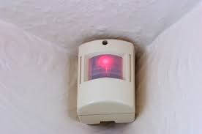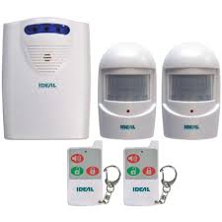 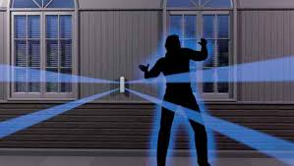
26
5.4 ALARMS ACCESSORIES
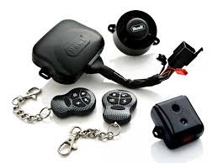 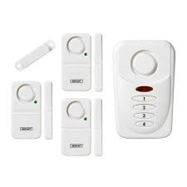 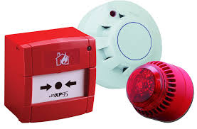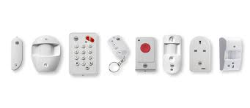
27
6.IT AND NETWORKING
28
7.MAINTENANCE
-At TRI-FORCE we have well trained staff who will provide all the services we serve to our clients
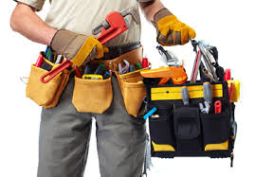
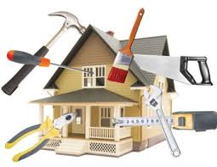
29

